17. Scenario: You are a data analyst working for a marketing research company. Your team has

collected a large dataset containing customer feedback from various social media platforms. The

dataset consists of thousands of text entries, and your task is to develop a Python program to

analyze the frequency distribution of words in this dataset. Your program should be able to perform

the following tasks:

• Load the dataset from a CSV file (data.csv) containing a single column named "feedback"

with each row representing a customer comment.

• Preprocess the text data by removing punctuation, converting all text to lowercase, and

eliminating any stop words (common words like "the," "and," "is," etc. that don't carry

significant meaning).

• Calculate the frequency distribution of words in the preprocessed dataset.

• Display the top N most frequent words and their corresponding frequencies, where N is

provided as user input.

• Plot a bar graph to visualize the top N most frequent words and their frequencies.

Question: Create a Python program that fulfills these requirements and helps your team gain

insights from the customer feedback data.

Code:

import pandas as pd

import string

import matplotlib.pyplot as plt

from collections import Counter

import re

import os

stop_words = {

'the', 'is', 'and', 'in', 'to', 'with', 'a', 'for', 'of', 'on', 'it', 'this',

'that', 'i', 'was', 'but', 'be', 'have', 'not', 'are', 'as', 'very', 'so', 'from'

}

file_path = os.path.join(r"C:\Users\jampa\Downloads\data.csv")

def load_data(filepath):

try:

df = pd.read_csv(filepath)

return df['feedback'].dropna().astype(str)

except Exception as e:

print("Error loading file:", e)

return pd.Series()

def preprocess(texts):

words = []

for text in texts:

text = text.lower()

text = re.sub(f"[{string.punctuation}]", "", text)

tokens = text.split()

tokens = [word for word in tokens if word not in stop_words]

words.extend(tokens)

return words

def plot_words(word_freq, n):

common = word_freq.most_common(n)

words, counts = zip(*common)

plt.figure(figsize=(8,3 ))

plt.bar(words, counts, color='orange')

plt.title(f"Top {n} Most Frequent Words")

plt.xlabel("Words")

plt.ylabel("Frequency")

plt.xticks(rotation=45)

plt.tight_layout()

plt.show()

def main():

feedback_data = load_data(file_path)

if feedback_data.empty:

print("No feedback data found.")

return

words = preprocess(feedback_data)

word_freq = Counter(words)

try:

n = int(input("Enter the number of top frequent words to display: "))

except ValueError:

print("Please enter a valid number.")

return

print(f"\nTop {n} Most Frequent Words:")

for word, count in word_freq.most_common(n):

print(f"{word}: {count}")

plot_words(word_freq, n)

if __name__ == "__main__":

main()

output:

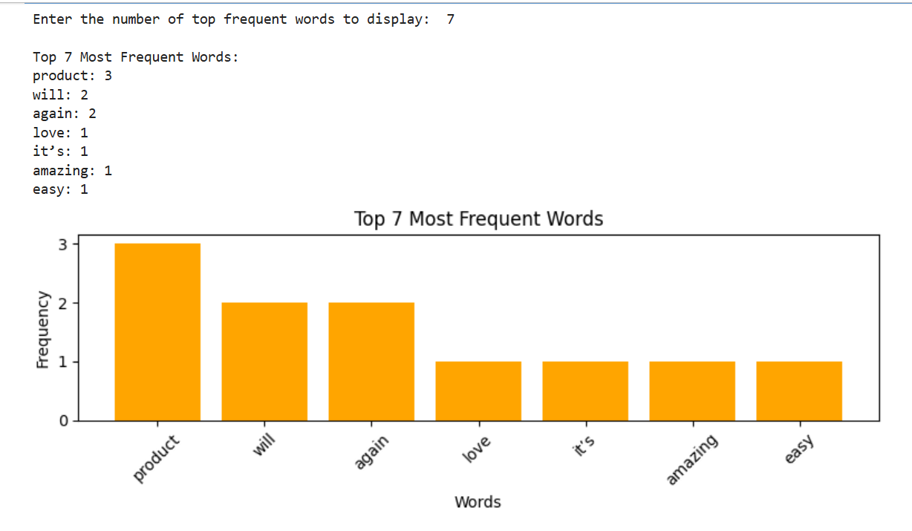

Dataset:

|  |  |  |  |  |
| --- | --- | --- | --- | --- |
| feedback |  |  |  |  |
| I love this product! Itâ€™s amazing and easy to use. | | | | |
| Terrible service. I will not buy from here again. | | | | |
| Good value for money. Highly recommended! | | | | |
| The product is okay, but delivery was slow. | | | |  |
| Excellent customer support. Very helpful and friendly. | | | | |
| Not satisfied with the quality. Could be better. | | | | |
| This is the best purchase I have made this year. | | | | |
| Poor packaging. The item was damaged on arrival. | | | | |
| Great experience overall. Will shop again! | | | |  |
| Average product. Nothing special, but not bad either. | | | | |